Progress Report – Bahder
Objective 1: Colony establishment has been successful however numbers to perform reliable numbers of replicates have not been reached. For establishment of the IAP, a total of 336 individuals have been collected from filed plots with no known LB infections. Cohorts of 20 individuals were exposed to spear leaf tissue taken from infected cabbage palms at daily intervals. Detection of the phytoplasma in the body was possible at 76 hours post exposure and detection of the phytoplasma in the salivary glads was possible at 8 days post exposure. All insects isolated on healthy tissue (negative controls) consistently tested negative throughout the 8-day period. The average number of individuals that acquired the phytoplasma in the salivary glands was 22%. Currently palms are being maintained until the population of H. crudus is high enough to conduct transmission assays.
Objective 2: In both central and north Florida sites, the peak population of H. crudus appears in late August and throughout September. Trends in south Florida are less evident with no consistent peak, however adults were consistently found throughout study period.
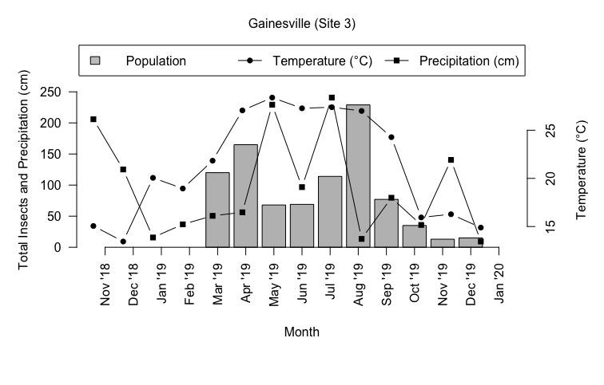
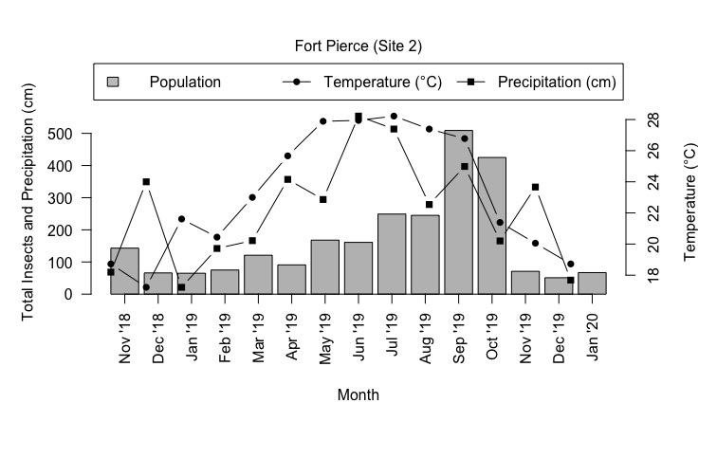
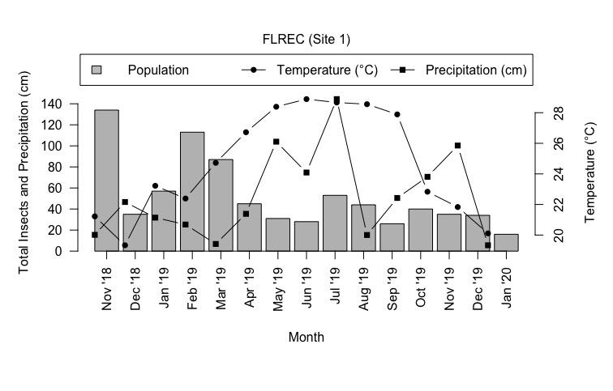

Objective 3: Thus far, a plot of Chinese fan palms has been sampled 5 times for the presence of nymphs. Each sampling date yielded 40 samples taken from ditches and beds. Data collected for the first 4 datasets shows that about 95% of the nymphs collected are from the ditches between beds.

