Project Title: Development of Begonias with Enhanced Heat Tolerance for Florida Nurseries
Annual Report Period: 08/2019-12/2019,
PI: Dr. Alfred Huo, Mid-Florida Research & Education Center, hhuo@ufl.edu

1) Copy of this cover sheet completed with original proposal

2) Brief summary of research project
The research funds were not allocated to PI (Dr. Huo) until the end of August, 2019. We have performed the experiments as proposed in the proposal with slight modifications. We have started to collect different begonia varieties (Rex Foliage Begonia, Wax Bedding Begonia, Tuber Potting Begonia). Crossing of intra and inter-species have been made, however, ill-development of embryos has been observed among many crossing probably due to incompatibility. We have obtained around 70 hybrid progenies from crossing of our heat tolerant begonia with different Wax Begonias. These progenies will be further evaluated for their abiotic stress tolerance and horticultural performance. Experiments for testing different chemical compounds (Melatonin, Salicylic Acid or both) for alleviating heat stress have been performed. Various growth characteristics including plant height, overall plant health, chlorophyll and anthocyanin content, leaf area, plant biomass, and plant chlorophyll florescence have been measured to determine the effects of both chemical compounds. Surprisingly, the preliminary observation and results indicate that the combination of both salicylic acid and melatonin exhibited detrimental effects on plant growth under heat stress in August, 2019. However, the treatment with Melatonin can significantly promote leaf expansion, especially under low light conditions. This experiment will be repeated in 2020 summer. Results from both years of experiments will be expected to be published as an extension paper or a peer-reviewed research journal. To understand the mechanism underlying the mechanism of heat tolerance of FB08-59 begonia, we will also perform anatomical comparison between FB08-59 and Bada Boom through microscopic examination of different organs, the results may be used as morphological markers for breeding selection. In addition, future effort will be given to cytogenetic analysis through examining the chromosome numbers of different varieties, which may provide fundamental basis for selecting parental varieties.
3) A report of specific research that has been conducted and any results or benefits that it has to the industry.
Activity 1: We have collected over 40 begonia species and accessions over the course of 2019 (Figure1). In the process, we have identified previously unknown species and hybrid in our original collection and have been in contact with multiple begonia collectors and breeders across the state.
https://drive.google.com/file/d/18t6C_TxWDp_x1rRnMiHjAfJC_iN_ni-i/view?usp=sharing
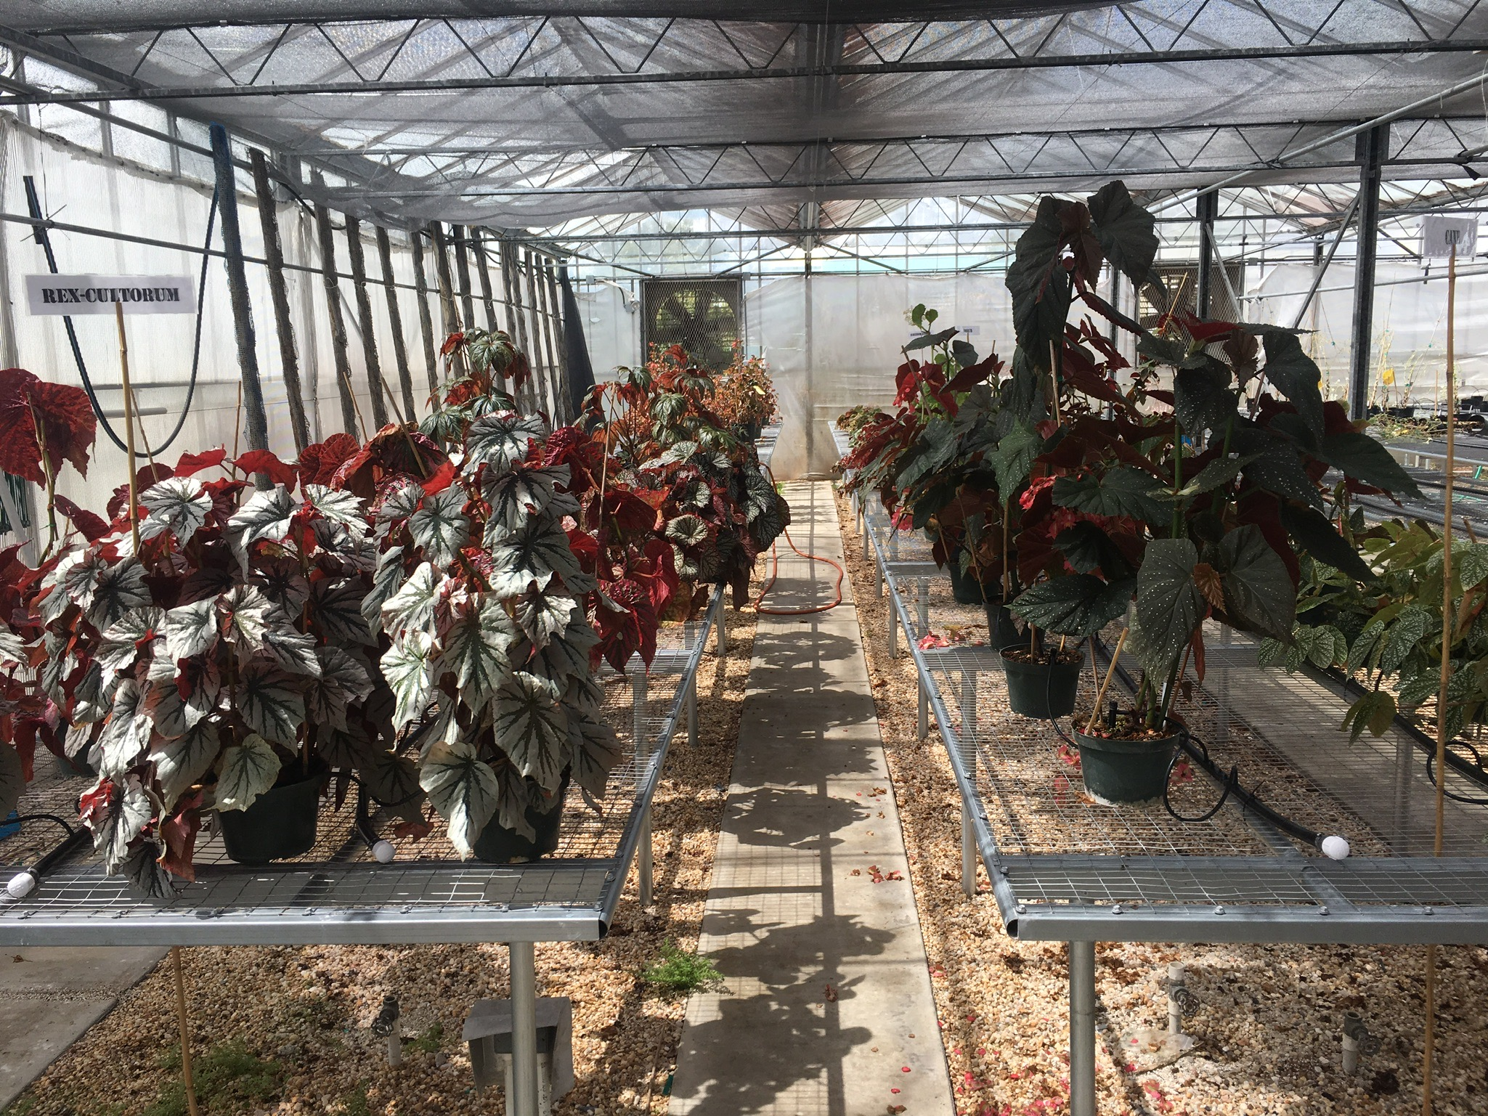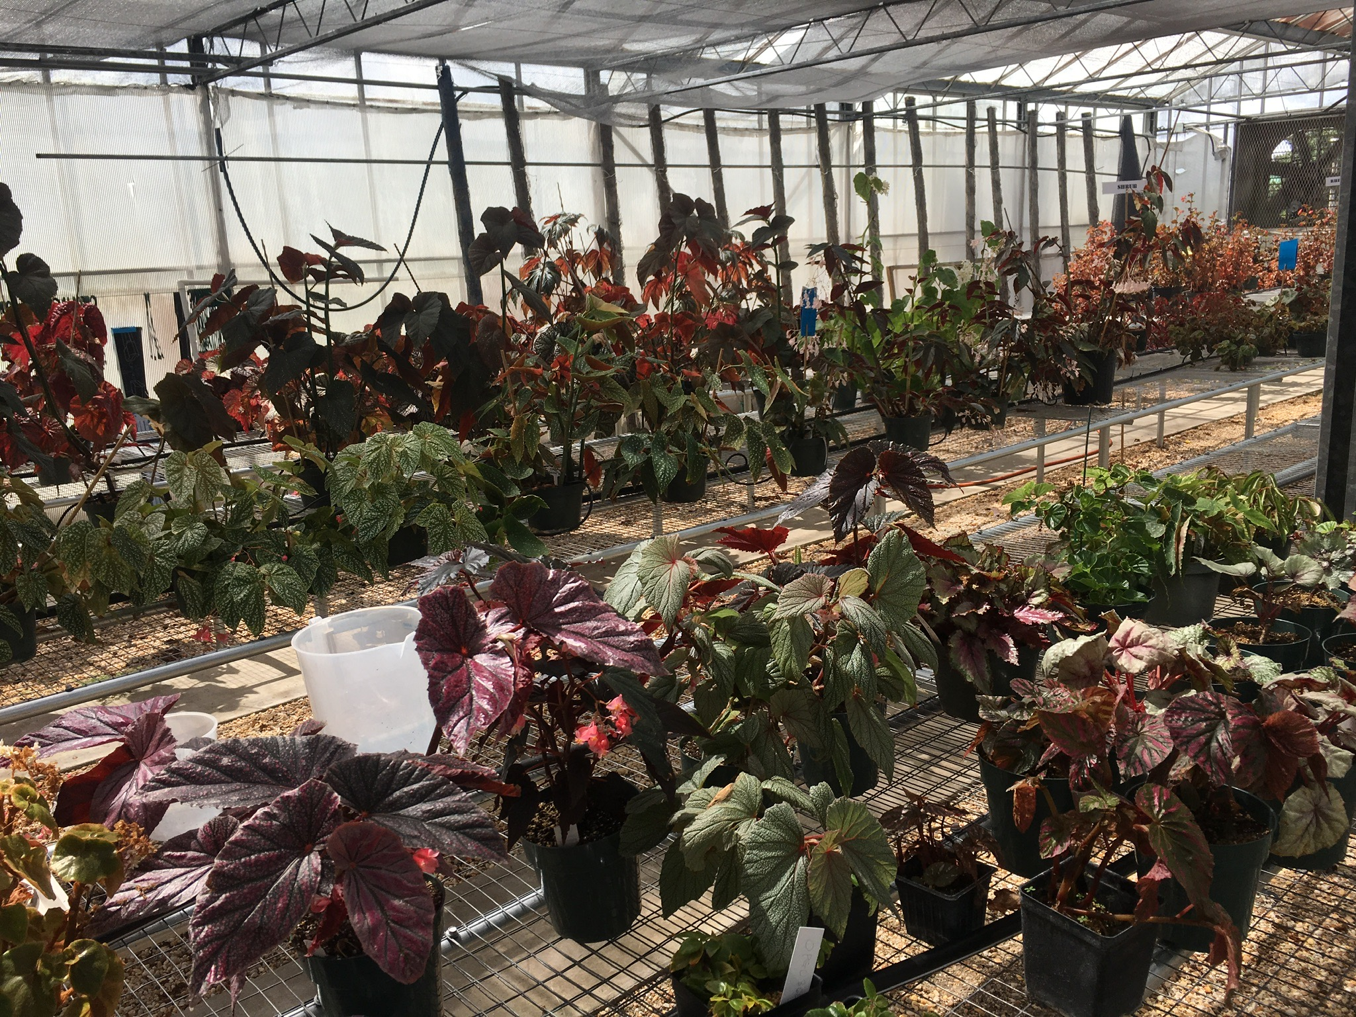
Figure 1 Begonia Germplasm
Activity 2: We have conducted over 150 interspecies and intra-species crosses over the course of 2019 in order to determine the reproductive viability of our varieties (Table 1). Only a very small percentage of crosses germinated successfully indicating that there may be enough genetic difference between species to inhibit proper germination. We plan on conducting a phylogenetic analysis to determine speciation in the genus Begonia.
Table 1. Different crossing for heat tolerant begonia breeding
Crossing
Male | Female
FB08-59 (heat-tolerant) | Lady Francis
FB08-59 (heat-tolerant) | Spirt mix pink
Jason (Drought tolerant) | OPGC 3563
FB08-59 (heat-tolerant) | Spitfire
Jason (Drought tolerant) | FB08-59 (heat-tolerant)
FB08-59 (heat-tolerant) | OPGC 3563
Jason (Drought tolerant) | FB08-163(sterile, heat tolerant)
FB08-59 (heat-tolerant) | Dade
FB08-59 (heat-tolerant) | Benigo
FB08-59 (heat-tolerant) | Sinbad
FB08-59 (heat-tolerant) | OPGC 3563
Bada Boom Pink | Self
FB08-59 (heat-tolerant) | OPGC 3143
FB08-59 (heat-tolerant) | Lady Francis
FB08-59 (heat-tolerant) | Kaylen
Sinbad | Terri (Kane)
FB08-59 (heat-tolerant) | OPGC 3563
Jason (Drought tolerant) | OPGC 3563
FB08-59 (heat-tolerant) | Concord Trail
Jason (Drought tolerant) | FB08-59 (heat-tolerant)

Activity 3: Melatonin and Salicylic Acid experiment: Different concentrations of melatonin, Salicylic Acid or both were applied to heat tolerant FB08-59 or heat sensitive Bada Boom. All plants were initially grown in low-light greenhouse prior to exposure to direct sunlight. Each treatment will have 3 repetitions of 3 samples. Both SA and Melatonin were sprayed on surface and underside of plants starting 10 days prior to experiment. Plant Height (length of tallest shoots), Plant overall health (any fungi, disease, damage to plants, overall color of plants), Anthocyanin/chlorophyll content and Fluorescence/Gas exchange were measured once a week; plant biomass and leaf area were determined in the end of this experiment. The treatment portion of the project began at the start of August and lasted 10 days. We then collected data on the samples over the course of 5 weeks. Results from this project will be further analyzed for 2nd experimental design and implementation in 2020.

4) If any portion of the research has been published, provide location of any professional or published information
One EDIS paper (extension publication) is in press; PI has deliver information on begonia breeding program in the FNGLA organized “Plant Health” workshop.

