Development of New Pothos Cultivars for the Foliage Plant Industry
Final Report
Jianjun Chen
December 22, 2020

The objectives of this project were to (1) optimize somatic embryogenesis systems for pothos regeneration, (2) select unique tissues of pothos cultivars for inducing somatic embryogenesis, and (3) select, characterize, and evaluate variants for releasing new pothos cultivars.

Results
1. An effective direct somatic embryogenesis system has been developed
Leaf explants were cultured on MS medium containing 4.54 μM TDZ with 1.07 μM NAA for inducing somatic embryos. Induced embryos converted to plantlets in the same medium.

2. The regeneration system was used for isolating variants
Unique variegated leaves have been used to produce explants, and leaf explants were cultured on the developed regeneration system to produce variants. Figure 1 shows some variants isolated from the culture.

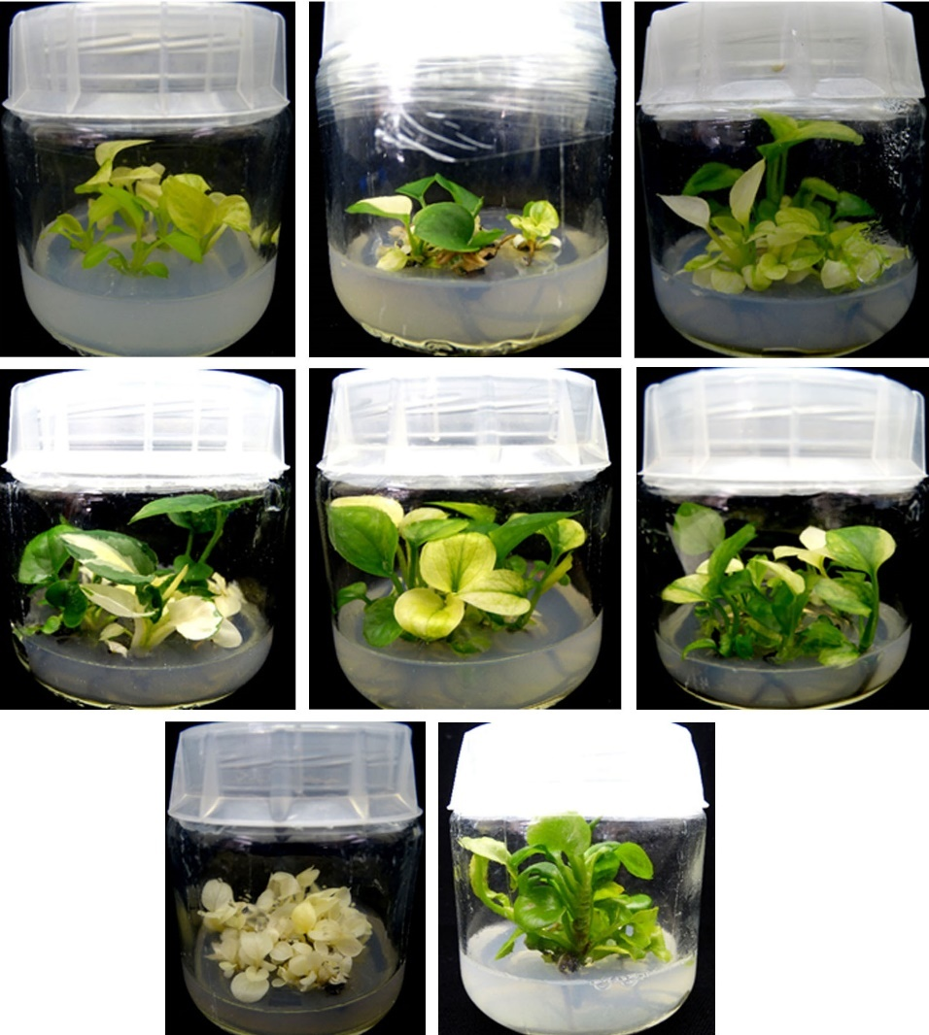

Figure 1. Plantlets or seedlings regenerated though direct somatic embryogenesis with leaves in different colors or variegation or seedlings with varied growth patterns.
3. Isolated variants were evaluated for potential release of new cultivars
We isolated 40 variants over the three-year period, from which nine appeared to be promising. These variants have been evaluated at the MREC shaded greenhouse, and they have been stable (Figure 2).

3.1. Nine selections
Figure 2 is the photos of nine selected new pothos followed by a brief description of their morphological characteristics.

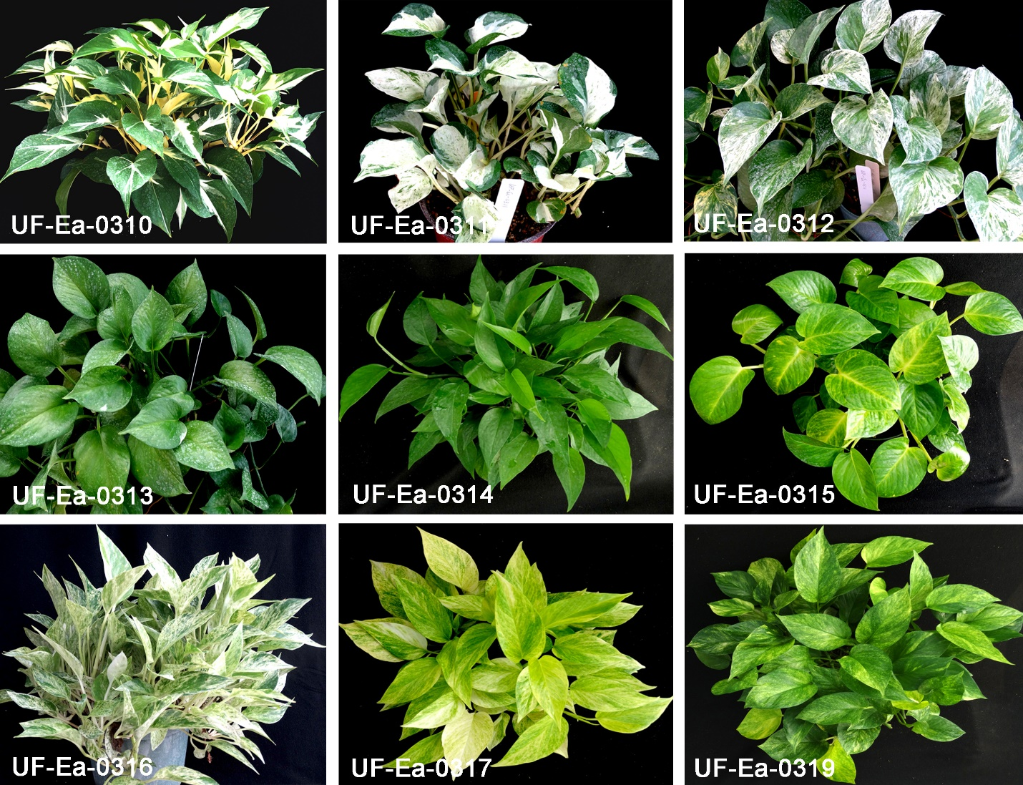

Figure 2. Morphology of the nine selected new pothos grown in the MREC shaded greenhouse.

UF-Ea-0310. Leaves: oblique with white-grey and green coloration; stem: white; leaf size: 14 cm long and 7 cm wide with an average area of 60 cm²; mean internode length: 4.0 cm.

UF-Ea-0311. Leaves: obtuse with white-grey and green coloration in irregular patches; stem: green and white lines; leaf size: 6 cm long and 6 cm wide with an average area of 30 cm²; mean internode length: 3.0 cm; a small compact plant.

UF-Ea-0312. Leaves: cordate with white-grey and green coloration; stem: green; leaf size: 12 cm long and 8 cm wide with an average area of 64 cm²; mean internode length: 6.0 cm; a tetraploid plant.

UF-Ea-0313. Leaves: cordate, complete green; stem: green; leaf size: 11 cm long and 7 cm wide with an average area of 54 cm²; mean internode length: 7.0 cm; a tetraploid plant.

UF-Ea-0314. Leaves: acuminate, tapering to a long point, complete green; stem: green; Leaf size: 10 cm long and 5 cm wide with an average area of 25 cm²; mean internode length: 7.0 cm.

UF-Ea-0315. Leaves: obtuse with pronounced yellow vein; stem: yellowish green; leaf size: 6 cm long and 6 cm wide with an average area of 32 cm²; mean internode length: 3.5 cm.

UF-Ea-0316. Leaves: lanceolate with white-grey and green coloration; stem: green; leaf size: 10 cm long and 4 cm wide with an average area of 24 cm²; mean internode length: 2.5 cm; a small compact plant.

UF-Ea-0317. Leaves: Aristate with light yellow and light greenish coloration; stem: yellow; leaf size: 6 cm long and 6 cm wide with an average area of 45 cm²; mean internode length: 5.5 cm.

UF-Ea-0319. Leaves: Aristate with greenish mock color interspersed by irregular light-yellow strips; stem: greenish yellow; leaf size: 6 cm long and 6 cm wide with an average area of 45 cm²; mean internode length: 5.5 cm.

3.2. Local nursery evaluation
Among the nine selections, UF-Ea-0310, UF-Ea-0314, UF-Ea-0316, and UF-Ea-0317 were evaluated by Mercer Botanicals, and UF-Ea-0310, UF-Ea-0314, and UF-Ea-0317 were evaluated by Wekiva Gardens in 2019. Comments from Mercer Botanicals included: slow growth, leaf scorching, and limited marketability. However, comments from Wekiva Gardens were more positive: both UF-Ea-0310 and UF-Ea-0317 have unique variegation patterns and have marketability. However, leaf scorching of variegated selections could be a problem.

3.3. Investigation of leaf scorching

Leaf scorching has been a problem for variegated selections. We have studied the cause of the problem and intended to develop methods for mitigating the problem. Our study found that this is caused by a combination of heat and high light. Photosystem II (PSII) in white sectors is much more sensitive to high light and high-temperature stress than green sectors. Under such growth conditions, the balance between the rate of PSII damage (induced by light stress) and the rate of PSII repair (impaired under heat stress) is broken, resulting in photoinhibition, thus leaf scorching of the white sectors. We found that 12-oxo phytodienoic acid (OPDA) in white sectors was 9-fold higher than green sectors. Commercially, OPDA is very expensive ($188 per milligram), and it is not practical to use it for alleviating the scorching problem. OPDA is related to jasmonic acid (JA), and the application of JA can also mitigate the problem, but JA is also expensive ($120 pe gram). We feel this could be a challenging problem and further research is needed.

3.4. Evaluation of chilling responses
Some selections were evaluated for chilling tolerance by exposing them to 0ºC (32ºF) for four hours. Plant responses to the chilling stress were shown in Figure 3. Commercial cultivars of Jade, Neon, and Pearls and Jade were highly injured. New selections of UF-Ea-0314, UF-Ea-0310, and UF-Ea-0311 had little damage. Two plants of UF-Ea-0317 were in the same pot, one was killed, but the other had no injury.

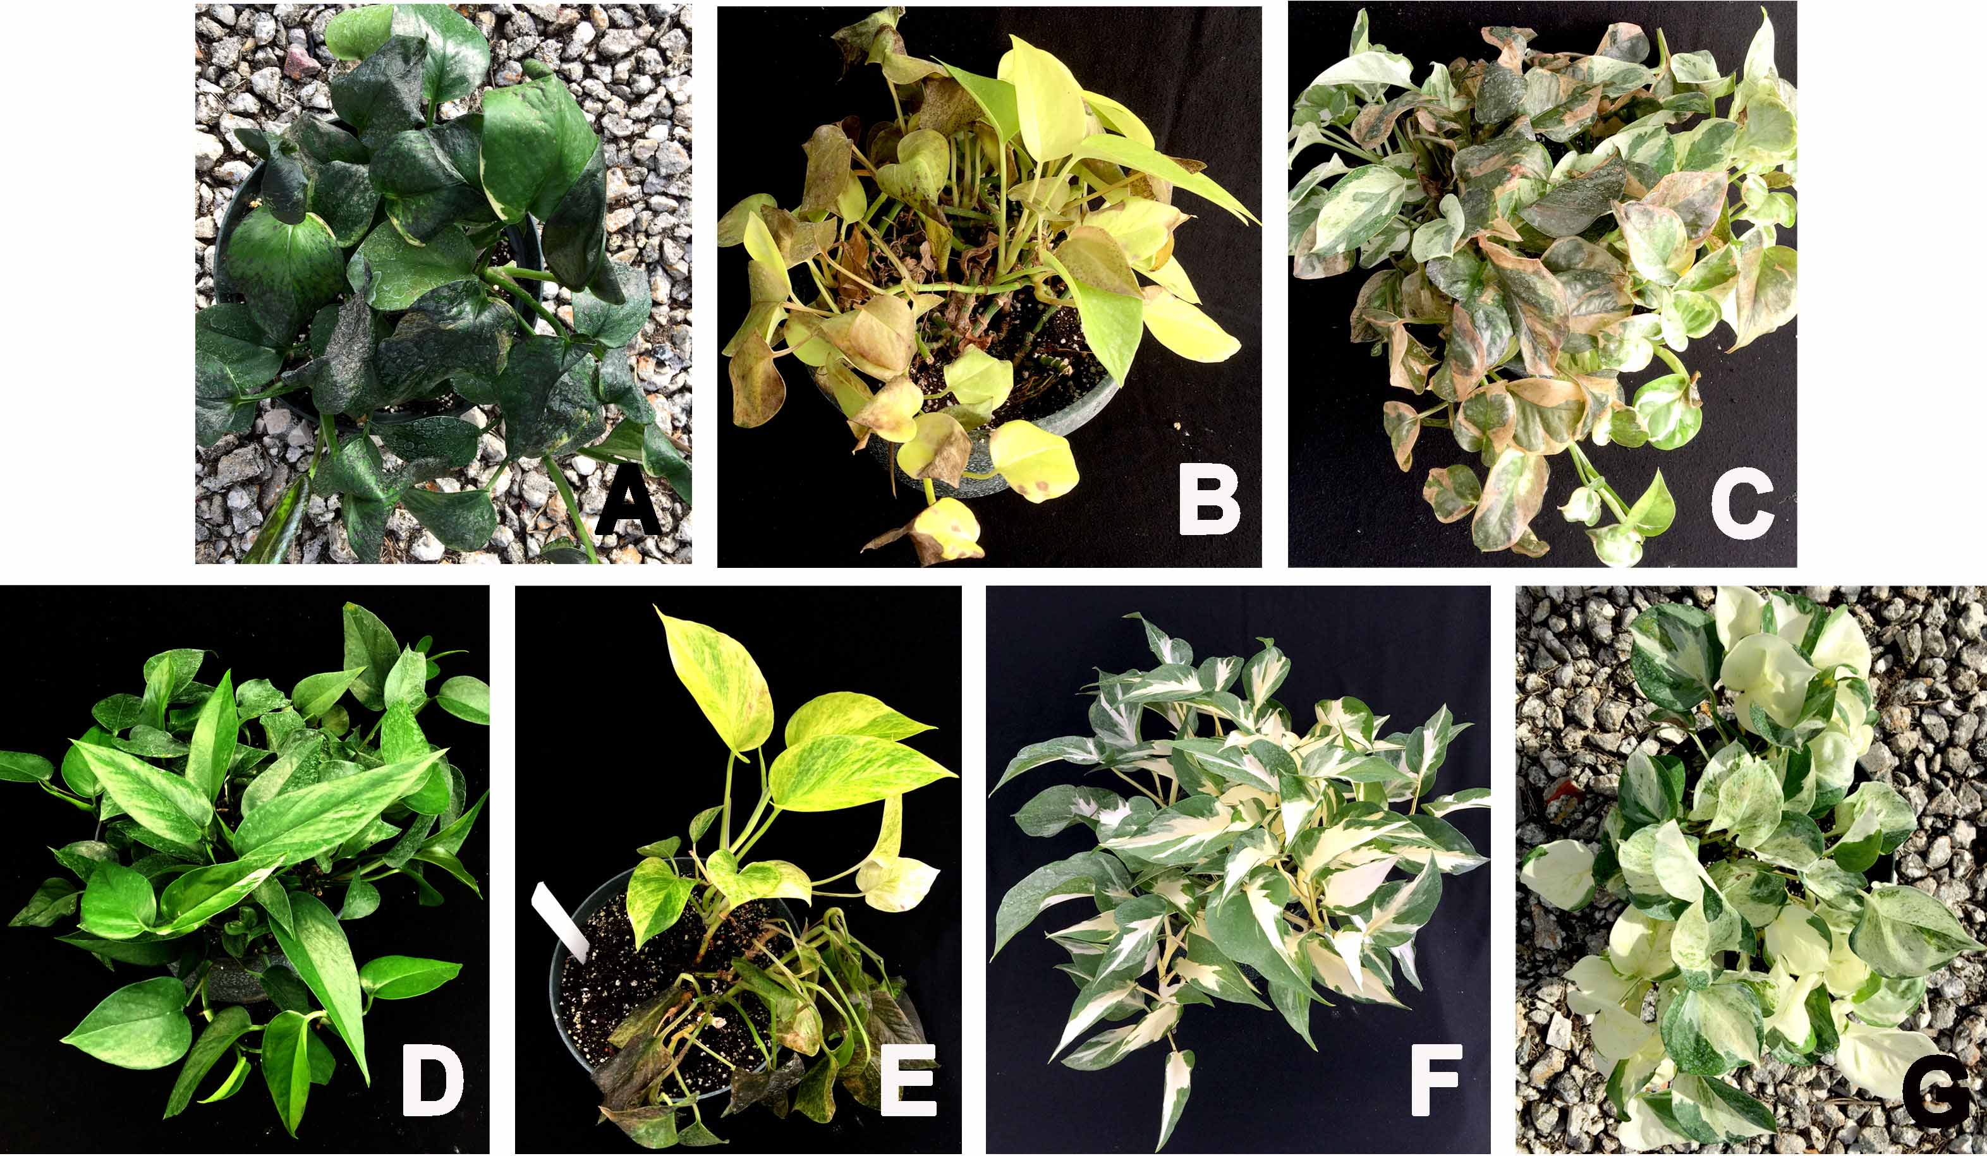

Figure 3. Pothos cultivar responses to a chilling temperature (0ºC or 32ºF) for 4 hr. A = Jade, B = Neon, C = Pearls and Jade, D = UF-Ea-0314, E = UF-Ea-0317, F = UF-Ea-0310, and G = E = UF-Ea-0311.

Summary

This project optimized the somatic embryogenesis system for pothos regeneration. Using the system, we isolated nine variants with unique patterns of foliage variegation or different ploidy levels. The variants have been stable with potential to be new pothos cultivars. Three of the nine variants (UF-Ea-0310, UF-Ea-0311, and UF-Ea-0317) exhibit leaf scoring during high temperature and relative high light intensity conditions. This is caused by the unbalance between the rate of PSII damage (induced by light stress) and the rate of PSII repair (impaired under heat stress), resulting in photoinhibition and leaf scorching of the white sectors. Further research is needed to dissolve the problem. Additionally, some variants (UF-Ea-0310, UF-Ea-0311, and UF-Ea-0314) showed more tolerance to chilling temperatures than the commercial cultivars, which indicates genetic variation among the variants in response to chilling temperatures.

Finally, I would like to thank the National Horticulture Foundation for supporting this project for the last three years.

